Muhammad Izham Bin Norhamadi  
B032020039  
S2G1

# Lab 6 Exercise Normalization

1) a)

Insertion Anomaly

* Insertion anomaly creates a dummy data problem. When a new employee needed to be registered in the system the entry immediately needs a contract, meaning that there can never be employee on standby.

Modification Anomaly

* Modification anomaly creates redundancy of updating multiple rows of same data. When the system needs to update an employee name, it also requires to update every row that occupies the name.

Deletion Anomaly

* Deletion anomaly forces unwanted data to be deleted with wanted data. If an employee quits their job, deleting the employee data will delete contracts aswell.

b)

**1NF**

**2NF**

**3NF**

2)

**1NF**

**2NF**

**3NF**

3) a)

Insertion Anomaly

* When more than one course served for a dinner the primary key of Dinner Num will repeat itself.

Modification Anomaly

* Changing a venue description will force changes to every venue with the same name.

Deletion Anomaly

* Deleting a member entry will also deletes other data such as dinner information

b)

**1NF**

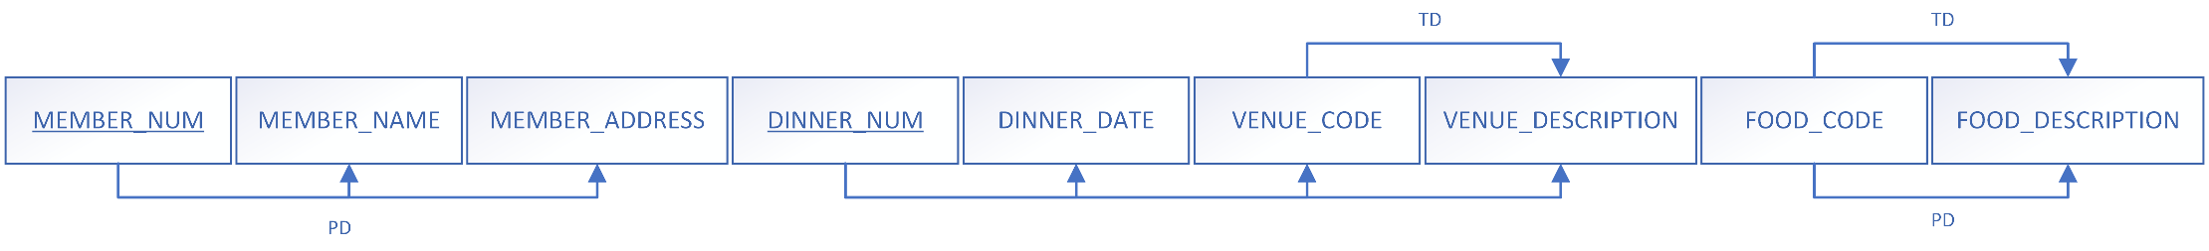

**2NF**

**3NF**

